To save data from the MSDA_XE software follow these steps.

1. Create a folder on your hard drive with the name of the survey eg: CE20001
2. Click on database

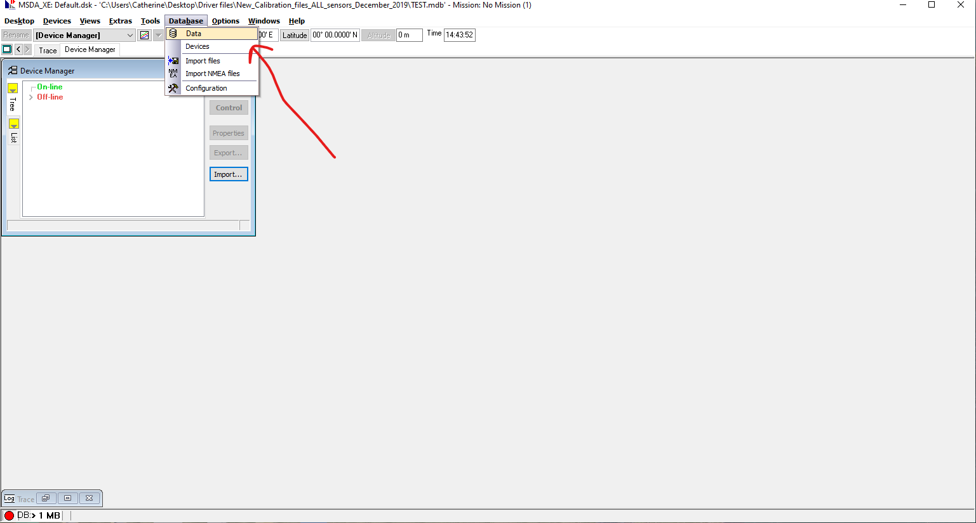

1. Select all in data base

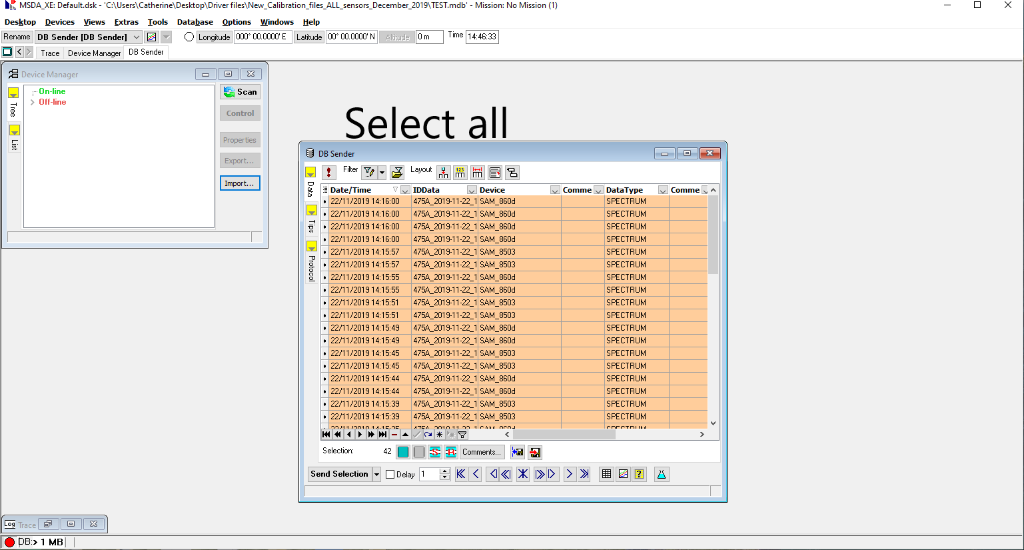

1. Export selected data to file

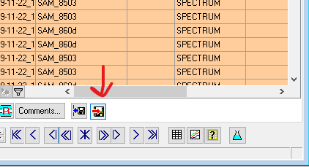

1. Select TriOS Format and Key
2. Choose directory by clicking on yellow folder

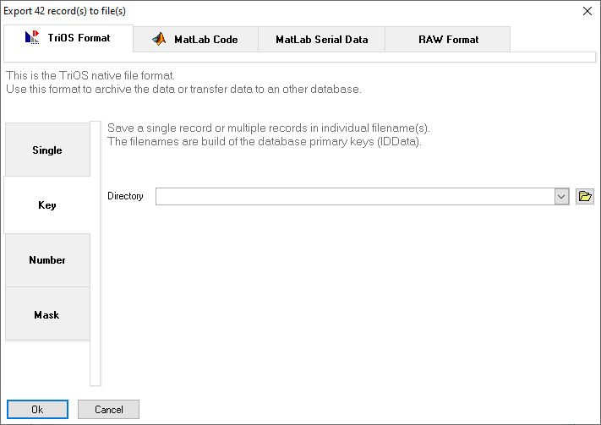

1. Select folder you created at the beginning with survey name, click Ok.

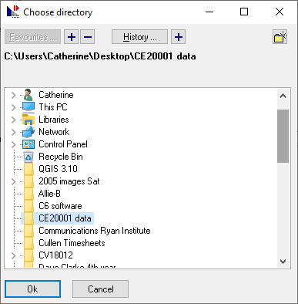

1. Confirm folder is correct and click Ok.

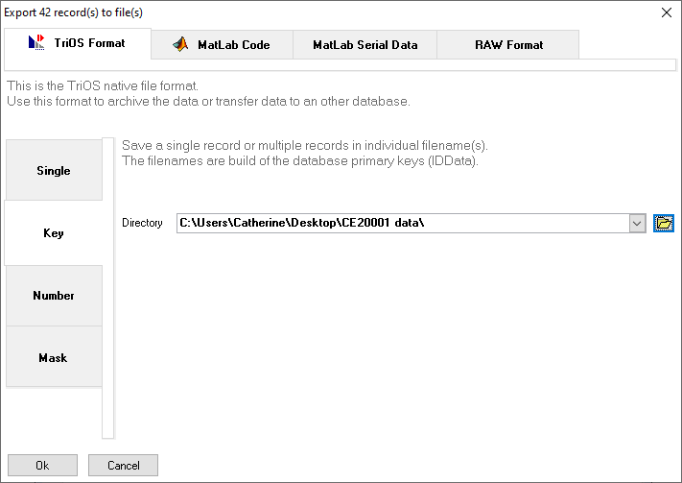

1. Export Finished message should appear after a while. May take a while if database has a lot in it

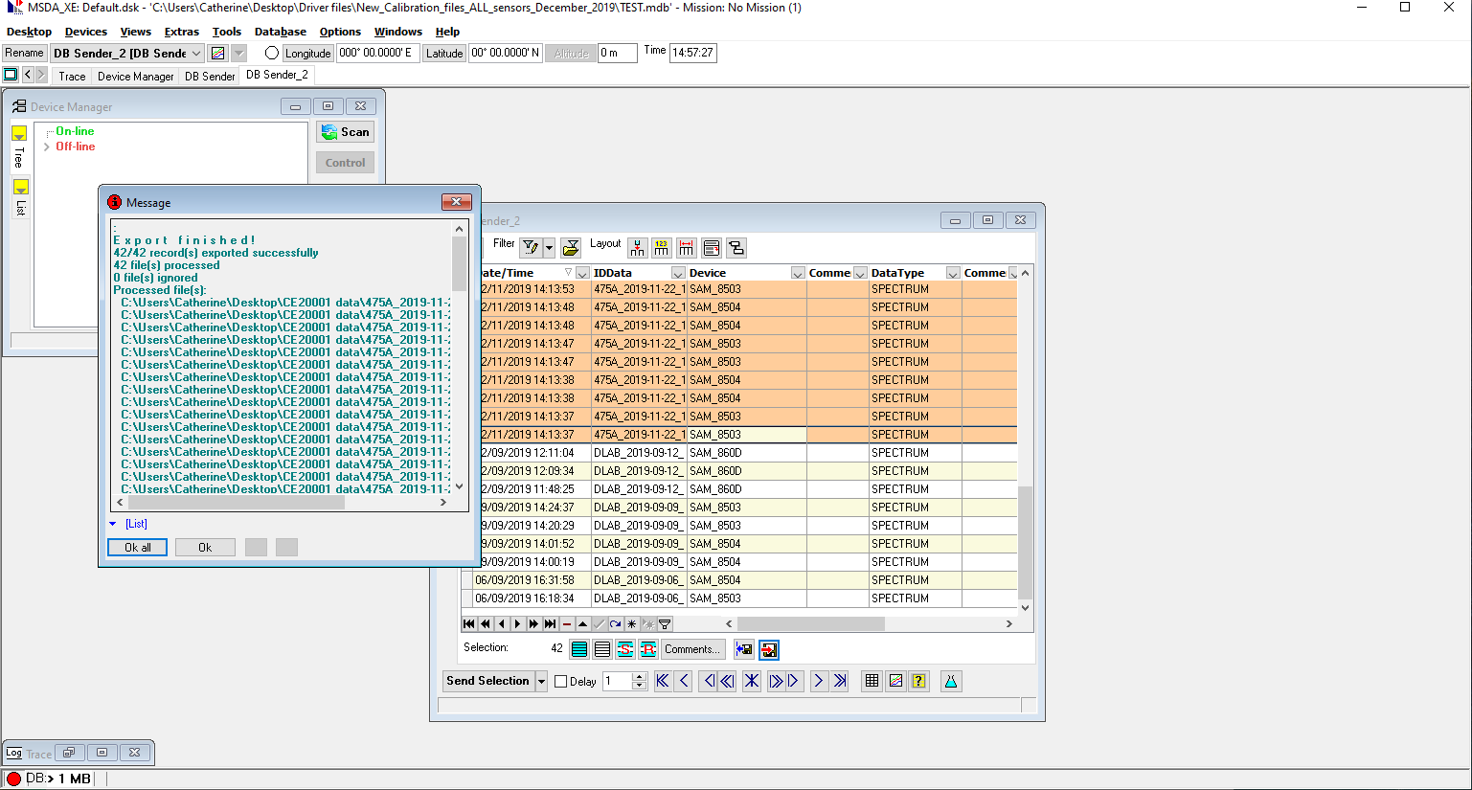

1. Finally, check folder to see if data saved in .dat format and looks like the folder below